LZ Deployment – Terraform

The repo folder structure is broken down in the following way:

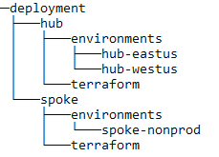 | Folder Descriptions  - hub – folder containing HUB artifacts  - environments  - workspace(s) – copy and paste as needed to create additional environments  - terraform – HUB Terraform code  - spoke – folder containing SPOKE artifacts  - environments  - workspace(s) – copy and paste as needed to create additional environments  - terraform – SPOKE terraform code
Setting up remote state
- Create a resource group and assign permissions
- Create a storage account, v1 or blob are good and cost less than v2
  - Make sure its set to private and SSL communication only
- Create a blob container named tfstate

Getting started with deployment
- First things first, copy the template code to the Azure DevOps project
- Clone the repo down to your machine so you can work with it
- Update the initial environment folder name to match the intended Terraform workspace name. For example, if you are deploying a HUB to East US, you might want to name the Terraform workspace hub-eastus. The environment folder must match this name.
- Update the backend settings in the terraform\versions.tf file to the correct storage account, container, and key.

Creating new environments
- Copy and paste one of the environment folders to a new folder within the environments folder. This folder should match your Terraform workspace.
- Update the settings (naming, IP address schema, etc)
- Create new pipeline in Azure DevOps using the pipeline yaml file within the folder
- Make sure to set the workspace name to match the environment folder name

Create an Azure DevOps pipeline
- Browse to the DevOps org and project
- Click pipelines on the left menu, then new pipeline in the top right
- Click Azure Repos Git as your code location
- Click the repo
- Click Existing Azure Pipelines YAML file
- Type in the path to the file and click continue

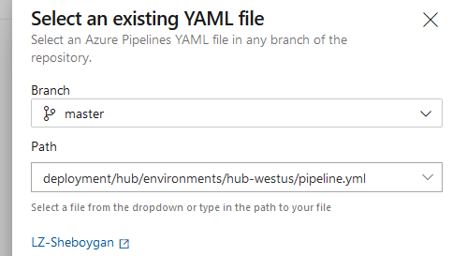

- Setup the variables by clicking the variables button on the top right. The variables that need to be added and passed into the pipeline are listed in the comments at the head of the pipeline YAML file. The workspace name is the Terraform workspace, which should match the environment folder.
- Click the arrow next to the run button and save the pipeline, but don’t run it yet
- Go back to pipelines, then click the whole tab
- On the far right of the pipeline name click the 3 dots button, then rename the pipeline to a descriptive name.

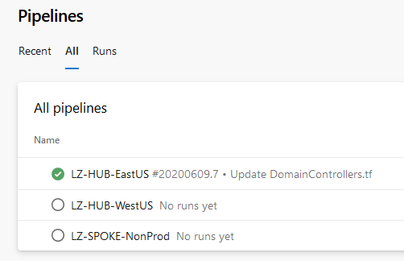
- Review the pipeline and settings, then you can run the pipeline

